FREE VIBRATION SDOF SYSTEM - expT PROCEDURE

AIM:

To find the damping (c) of the given beam.

PROCEDURE:

Begin the experiment by clicking the start experiment button.
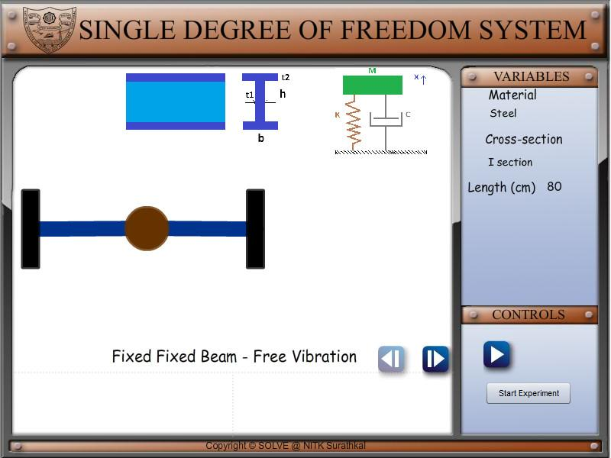

1. Find logarithmic decrement (δ) from displaceme

The logarithmic decrement is defined as follows.
δ= | 1 | ln | x
δ= | n | ln | x
Here x and x refer to the displacements at the first and n^{th} peak in the displacement v/s time graph. The displacements at the peaks can be found using the location slider.
FREE VIBRATION SDOF SYSTEM - expT PROCEDURE
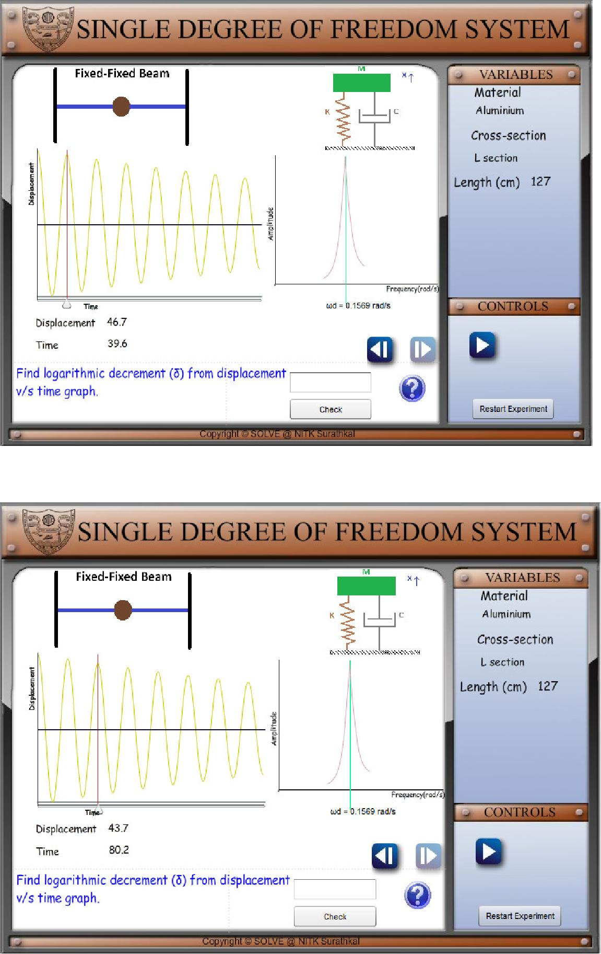
FREE VIBRATION SDOF SYSTEM - expT PROCEDURE

2. Find the damping ratiothelgarithmic(ζ)from.Thedecrementdampingratioisgiven by(δ)
ζ=
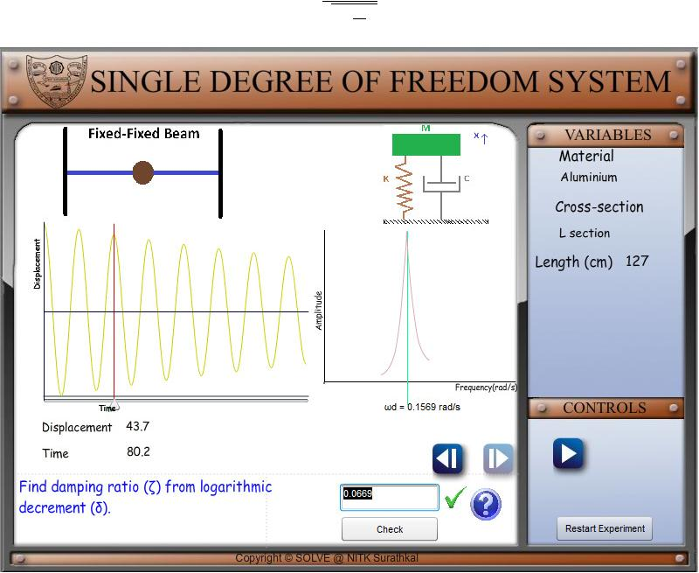

- Find beam stiffness (k) N/m from Young’s modulus (E), area moment of inertia (I) and length (L). The stiffness for different beams is given below.

Cantilever beam | = |  | 3
Simply supported beam | = |  | 48
Fixed Fixed beam | = | 192

FREE VIBRATION SDOF SYSTEM - expT PROCEDURE
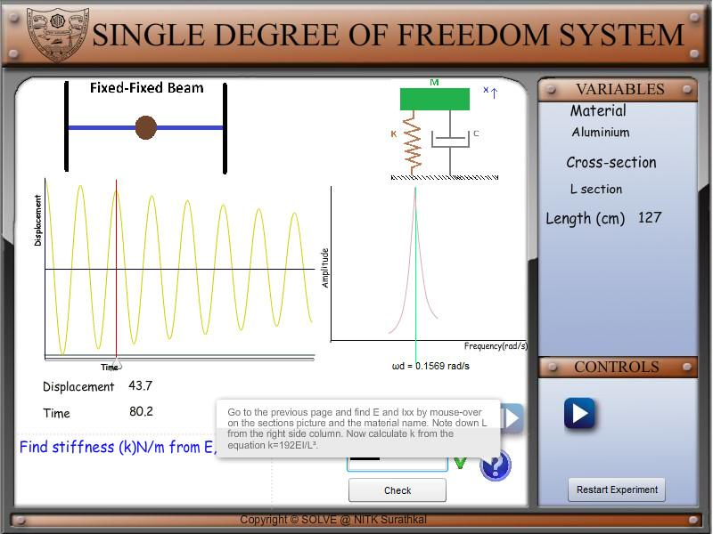

- Find natural) frequerad/sanfromcyd.ω_{d}ζcan(ωfound from the FFT in the graph window.

1 −
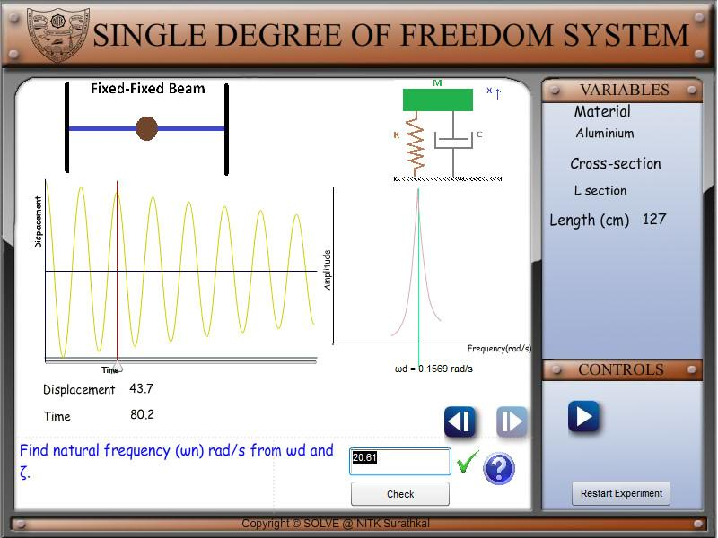
FREE VIBRATION SDOF SYSTEM - expT PROCEDURE

5. Find equivalent mass (m_{eq}) kg _{n} fromandk. ω
=
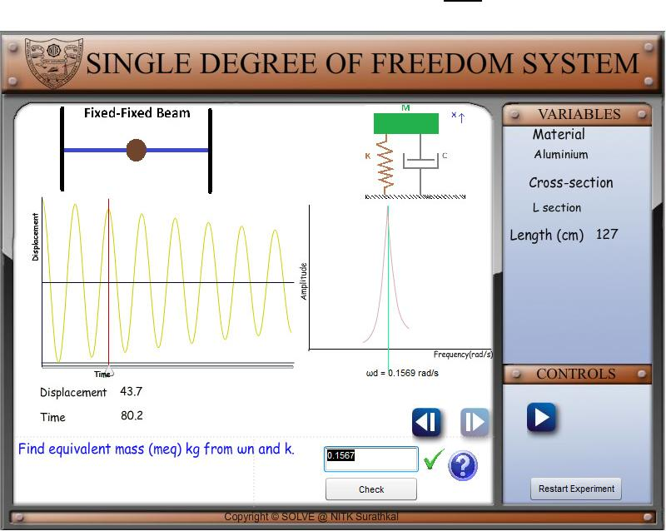

- Find critical damping (c_{c}) Ns/m from m_{eq} and k.
  - 2√
7. Find damping (c) Ns/m from. Cc and ζ
=
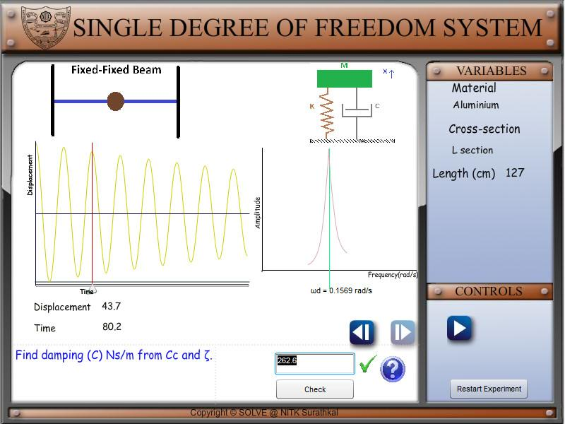
FREE VIBRATION SDOF SYSTEM - expT PROCEDURE

RESULT:

System damping ‘c’ has been found. The basic concepts in free vibration of SDOF systems are covered.
